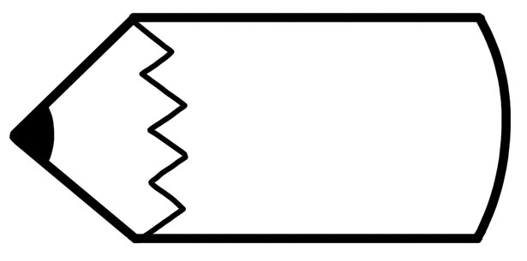3rd Grade Syllabus

Assignments

* Students receive a weekly/bi-weekly newsletter for Wonders (ELA).
* Classwork is assigned daily. Should students not complete work during class, they will be expected to complete unfinished work and return it the next day with their regular homework.
* A Math lesson is assigned daily, and Homework given M-Th.
* All other assignments must be completed and turned in by the due date given.
* When you sign your child’s agenda, you verify that unfinished classwork and assigned homework is complete. Parent signatures are included as part of Homework procedures.

Assessments

* Assessments are given weekly on Friday or at the conclusion of a Math, Social Studies, or Science Topic.
* Social Studies and Science study guides are given prior to the test and the test date is on the study guide.
* Assessments will be given on the computer apps in Classlink for Saavas Math, Wonders ELA ConnectED, Google Classroom, and on paper.
* All assessments are completed in class.

Feedback/Grades

* An Assessment Packet will be sent home on Thursday. Please review your child’s tests, sign the packet and return it on Friday.
* Teachers will give feedback directly to each student.
* Teachers will notify the student and parent of missing assignments,
* Teachers may communicate with parents regarding student progress.

Let's work together to make it a great year!